PROPUNERE SUBIECT OLIMPIADA DE LIMBA ENGLEZᾸ
ETAPA LOCALᾸ
CLASA a X-a
SECȚIUNEA B

• Toate subiectele sunt obligatorii
• Nu se acordă puncte din oficiu
• Timpul efectiv de lucru este de 3 ore

SUBIECTUL A
USE OF ENGLISH (40 points)

I. Read the paragraph below and do the tasks that follow.
As a young woman in the city of Montgomery, Alabama, in the Deep South of the United States, Rosa Parks became a heroine and role model for millions because she defied authority. Travelling home on a Montgomery bus one day in 1955, Rosa had the gall to sit down in one of the empty seats at the front, seats reserved for Whites only. When the driver noticed, he immediately stopped the bus, and ordered Rosa to go to the back of the bus. Rosa defied his authority. The driver repeated his order "Go to the back!" Again and again Rosa defied him; in the end, the authorities were called, and they hauled Rosa Parks off the bus and arrested her. She was fined $10 - a large sum in those days. Yet Rosa’s defiance of authority was to have repercussions throughout the USA; it is more than sure that this act was the one that ignited the whole Civil Rights movement in the United States of America, and gave hope to similar movements in other parts of the world. As Rosa faced down authority in that city over half a century ago, little did she imagine that she would one day receive the highest honour of the State of Alabama. At the end of the year 2000, Rosa Parks, then an elderly lady, became the first recipient of the "Governor's Medal of Honor for Extraordinary Courage", a new award designed to honour those who demonstrate extraordinary acts of courage that have a lasting impact on the lives of others. Though Blacks and Whites had, in theory, been equal citizens in the USA since the days of emancipation, even in 1950, they did not benefit from equal rights. Segregation was particularly severe in the states of the Old South, those states that had fought a civil war in defense of slavery less than 100 years previously. In December 1956, the Supreme Court ruled that Alabama’s segregation laws were unconstitutional; and another big fight in the struggle for Civil Rights had been won. A few days later, a young black minister, Reverend Martin Luther King, sat just where Rosa had sat a year earlier in a Montgomery bus, and no one told him to move. The long struggle for Civil Rights was not over, but a major battle had been won. We are all deeply indebted to this wonderful woman. If it hadn’t been for Rosa Park’s courage and determination, things wouldn’t have evolved so quickly.

A. Choose the right synonym for the words given below, according to their meaning in the text. (3 points)
1. gall: a) defiance b) boldness c) civility d) consideration
2. repercussions: a) repetitions b) consequences c) reactions d) punishment
3. are indebted to: a) owe money to b) owe an explanation to c) owe nothing to d) owe respect to
B. Rephrase the following sentences so as to preserve the meaning. (3 points)

- The authorities hauled Rosa Parks off the bus and arrested her.
Rosa Parks……………………………………………………by the authorities.
- If it hadn’t been for Rosa Park’s courage and determination, things wouldn’t have evolved so quickly.
But for…………………, things wouldn’t have evolved so quickly.
3. It is more than sure that this act was the one that ignited the whole Civil Rights movement in the United States of America.
This act……………………………………. the one that ignited the whole Civil Rights movement in the United States of America.

C. Sum up the text. (4 points)

II. For questions 1-10, read the text below. Use the word given in capitals at the end of some of the lines to form a word that fits in the gap in the same line. There is an example at the beginning: (10 points)

Koalas are often called 'bears' but this is (0) INACCURATE as a koala ACCURATE
is not a bear, but a marsupial - a mammal whose young are carried by the female
in a pouch. Koalas are found in coastal regions of eastern and southern
Australia, but can also be found a considerable (1)…from the sea, DISTANT
in areas with enough moisture to support the type of woodlands which
are (2) ... for them. A koala’s average life expectancy is about SUIT
twelve years, but if its habitat is quiet and (3) …,it will live longer DISTURB
than if it lives in a built-up area. The (4)…of a koala varies from WEIGH
about five to fourteen kilograms.
The habitat requirements of a koala include the (5)...of eucalyptus PRESENT
trees. The higher the (6) …of these trees, the better the habitat DENSE
quality. Koalas can eat (7)… 350 grams of leaves a day. However, APPROXIMATE
the leaves from the eucalyptus can be extremely ….(8). To POISON
overcome this problem, the koala removes any (9)…chemicals HARM
from the leaves with the aid of a specially adapted digestive system. As
the leaves are not a very good source of calories, energy (10) …is CONSERVE
a high priority for the animal. It achieves this by sleeping up to sixteen
hours a day.

III. Correct the errors in each sentence: (10 points)

1. Kate claims that if she got an MBA after finishing her bachelor’s degree, she might have been considered for the position.
2. It was a frustrating situation because we were uncapable of helping.
3. The four participants discussed it between themselves.
4. He told me that he had never been in that restaurant before.
5. Never before I have seen him that miserable!
6. We regret informing you that your application has been denied.
7. We thought we were going to expand this year, but we actually have less people now than we did two years ago.
8. I’m so glad that he spoke in my behalf because I felt awful that I couldn’t make it to the event.
9. If you would’ve told me, I would have given you my honest advice.
10. She’s trying to concentrate herself on finishing her degree.

IV. Translate the following text into English. (10 points)

Într-o după-amiază târzie, așteptând să vină un autobuz pentru Fifth Avenue, am observat un taxi care s-a oprit vizavi și din care a ieșit o fată care a urcat în goană treptele bibliotecii publice. Se prea poate să fi fost Holly. A intrat repede pe ușă și n-am apucat s-o identific, lucru scuzabil, căci cine s-ar fi gândit că o fată ca Holly ar merge la bibliotecă? Împins de curiozitate, am intrat în bibliotecă, încercând să mă hotărăsc dacă să recunosc că am urmat-o acolo sau să mă prefac că nu e decât o coincidență. Până la urmă n-am făcut nici una, nici alta, ci m-am ascuns câteva mese mai încolo, în camera de lectură, unde ea ședea la adăpostul ochelarilor ei fumurii și a fortăreței de cărți adunate pe masă. Trecea iute de la o carte la alta, zăbovind din când în când asupra unei pagini, veșnic încruntată, de parcă literele erau cu susul în jos. (Truman Capote - Breakfast at Tiffany’s, text adaptat)

SUBIECTUL B
INTEGRATED SKILLS (60 points)

- Reading comprehension (10 points)
You are going to read an article about the traditional Japanese sport of sumo wrestling. Five sentences have been removed from the article. Choose from the sentences A-F the one which fits each gap (9-13). There is one extra sentence which you do not need to use.

A Women are even at an advantage because of their body shape.

B Each contest might last only seconds, but high levels of physical effort are required.

C So what is the likelihood of it becoming popular among women?

D Despite some protests from traditionalists, there are numerous women-only sumo contests and a female world champion.

E This involves charging and pushing another wrestler across the ring until both parties are red-faced and sweating.

F The Japanese art is also a great way to deal with stress.

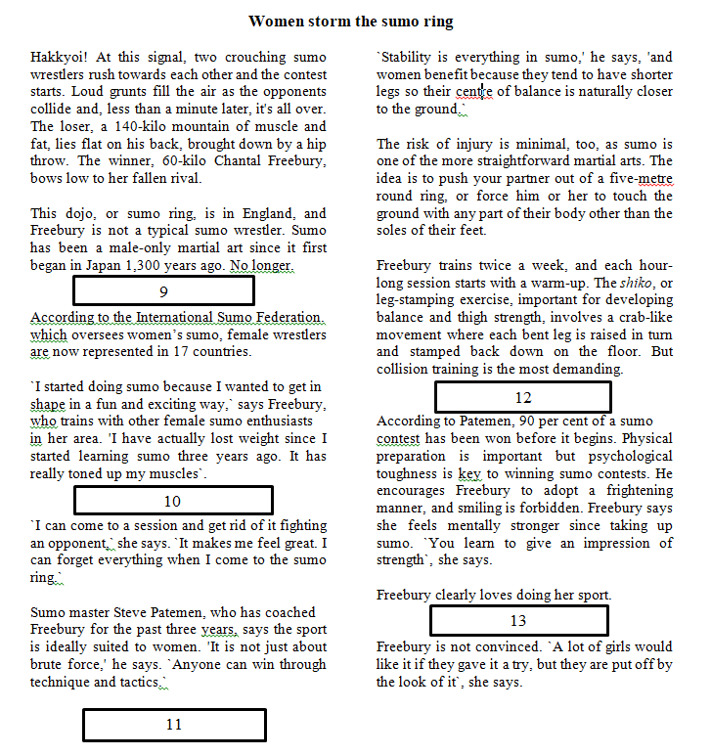

II. Functional writing (50p)

An international sporting organisation has asked your college for information about its students’ involvement in sports. As you are the school’s representative, Mrs. Anna Jones, the college principal, has asked you to write a report summarizing your school’s attitude to sport. You should provide information about your school’s interest in sport both as participants and as spectators and should suggest at least one way in which the college could do more to encourage students’ involvement in sport. Write your report.

MARKING SCHEME

• Se punctează oricare alte modalităţi de rezolvare corectă a cerinţelor.
• Nu se acordă puncte din oficiu.

SUBIECTUL A
USE OF ENGLISH (40 points)

I. 10 points
A. 3 points - 1.b 2 b 3 d
B. 3 points
1. Rosa Parks was hauled off the bus and arrested by the authorities.
2. But for Rosa Park’s courage and determination, things wouldn’t have evolved so quickly.
3. This act must have been the one that ignited the whole Civil Rights movement in the United States of America.
C. 4 points - Students’ own answers

II. 10 points
1. Distance 2. Suitable 3. Undisturbed 4.Weight 5.Presence 6.Density 7.Approximately
8. Poisonous 9. Harmful 10. Conservation

III. 10 points
1. Kate claims that if she got had got an MBA after finishing her bachelor’s degree, she might have been considered for the position
2. It was a frustrating situation because we were incapable of helping.
3. The four participants discussed it among themselves.
4. He told me that he had never been to that restaurant before.
5. Never before have I seen him that miserable!
6. We regret to inform you that your application has been denied.
7. We thought we were going to expand this year, but we actually have fewer people now than we did two years ago.
8. I’m so glad that he spoke on my behalf because I felt awful that I couldn’t make it to the event.
9. If you had told me, I would have given you my honest advice.
10. She’s trying to concentrate herself on finishing her degree.

IV. 10 points
Suggested answer
Late one afternoon, while waiting for a Fifth Avenue bus, I noticed a taxi stop across the street to let out a girl who ran up the steps of the public library. It might have been Holly. She went through the doors before I recognized her, which was pardonable, for Holly and libraries were not an easy association to make. I let curiosity guide me inside, debating on the way whether I should admit following her or pretend coincidence. In the end I did neither, but concealed myself some tables away from her in the reading room, where she was sitting behind her dark glasses and a fortress of books she had gathered on the desk. She was speeding from one book to the next, lingering, once in a while, on a page, always frowning, as if the letters were printed upside down. (Truman Capote - Breakfast at Tiffany’s, adapted)

SUBIECTUL B
INTEGRATED SKILLS (60 points)

I. Reading comprehension (10 points)
9D 10F 11A 12E 13C
II. Functional writing - REPORT (50 points)

