LESSON PROJECT

TEACHER: Vlăsceanu Roxana
SCHOOL: Colegiul Național Pedagogic Spiru Haret, Focșani
GRADE: XE (3h/L1)
NUMBER OF STUDENTS: 28
TEXTBOOK: FCE Gold Plus, Pearson and Longman
UNIT: Strange but true
LESSON: Crime, Mystery
DATE: 31.03.2021
TYPE OF LESSON: Acquisition of new knowledge
SKILLS DEVELOPED: speaking and listening
LESSON AIMS: by the end of the lesson students will:
- activate prior knowledge connected to crime and punishment
- acquire new vocabulary connected to and use it in utterances of their own
- be able to extract general and specific information from an audio recording
- talk about different problems and provide solutions
AIDS: - notebooks
- computer
- speaker
- Students’ mobile phones/ computers
TECHINIQUES: FW, GW, IW
INTERACTIONS: T-S, S-S, S-T

ANTICIPATED PROBLEMS:
- Some students might have trouble understanding the audio track, in which case the file will be played twice.
- In case there is time left, there will be an extra activity consisting of students reading and solving some tasks.

ACCOMMODATIONS FOR DIFFERENTIATED LEARNERS:
- Students will be provided with extra work at home; they will present what they have learned during next class.
- Students with difficulties in doing the tasks will be allowed extra time to solve them, will be allowed to use their first language after which the teacher will guide them to say the same thing in the target language.
CLASS DEVELOPMENT
Activity 1 – Warm-up
Interaction: T-S, S-T
Technique: FW
Aids: class register, computer
Time: 13 minutes
Aim: by the end of the activity the students will be familiar with the subject and objectives of the lesson.
Procedure: The teacher greets the students, takes attendance and checks their homework. The students will have to present their project work about crime and punishment in literature William Shakespeare – The Tragedy of Julius Caesar. They are divided in 4 teams and each one will present its part.
Activity 2 – Lead-in
Interaction: T-S, S-T
Technique: FW
Aids: computer
Time: 10 minutes
Aim: by the end of the activity students will be able to extract information from a video showing “Detective Sniffnose”
Procedure: By referring to the same video, the teacher asks the students to mention other examples of detective stories, movies, books.
Activity 3 – Vocabulary
Interaction: T-S, S-S, S-T
Technique: FW, GW
Aids: book
Time: 5 minutes
Aim: by the end of the activity students will acquire new vocabulary related to theme
Procedure: The teacher asks the students to read the questions from exercise 1, page 147 and to answer to them.

Activity 4 –Listening for general understanding
Interaction: T-S, S-S, S-T
Technique: IW, GW
Aids: speakers, book
Time: 4 minutes
Aim: by the end of the activity students will be able to extract general information from an audio recording about a movie.
Procedure: The teacher tells the students to open the book at page 147 where there is a song from a movie. The teacher plays the recording and the students listen for the task, after which they will be allowed two minutes to check their work in groups. At the end of the activity, the teacher checks the students’ answers orally.

Activity 5 – Listening for specific purposes
Interaction: T-S, S-S, S-T
Technique: IW, GW
Aids: speaker, worksheets
Time: 6 minutes
Aim: by the end of the activity students will be able to extract specific information from an audio
Procedure: The teacher asks the students to read the words and the teacher makes sure that they understand them. The teacher plays the recording and the students listen for the task, after which they correct the if they have mistaken.
Activity 6 – Feedback and evaluation
Interaction: T-S, S-T
Technique: FW
Time: 2 minutes
Aims: by the end of the activity the students will be able to use the newly acquired vocabulary in utterances of their own.
The teacher congratulates the students for their work and grades those who were the most active during the class.

The theme of the project from Activity 1

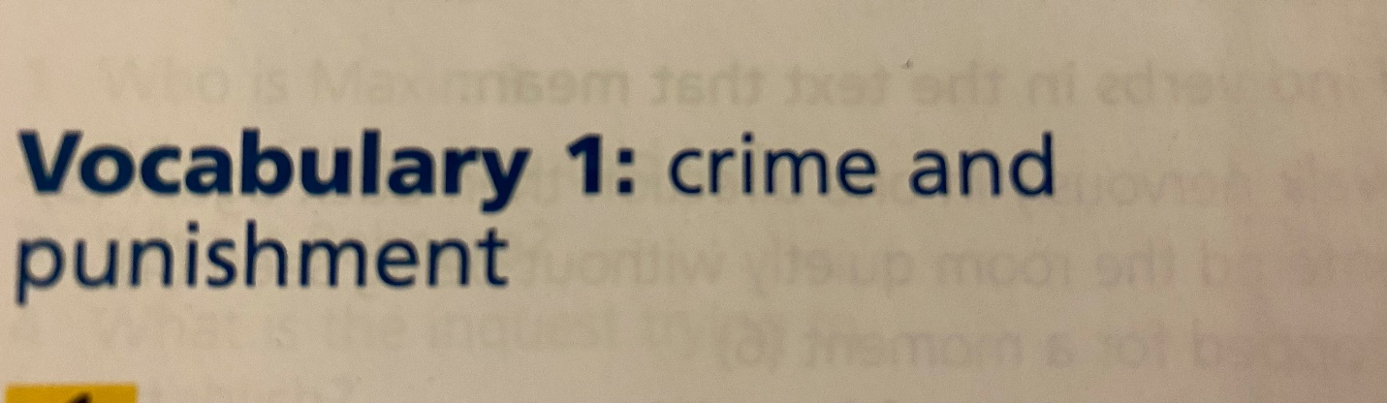

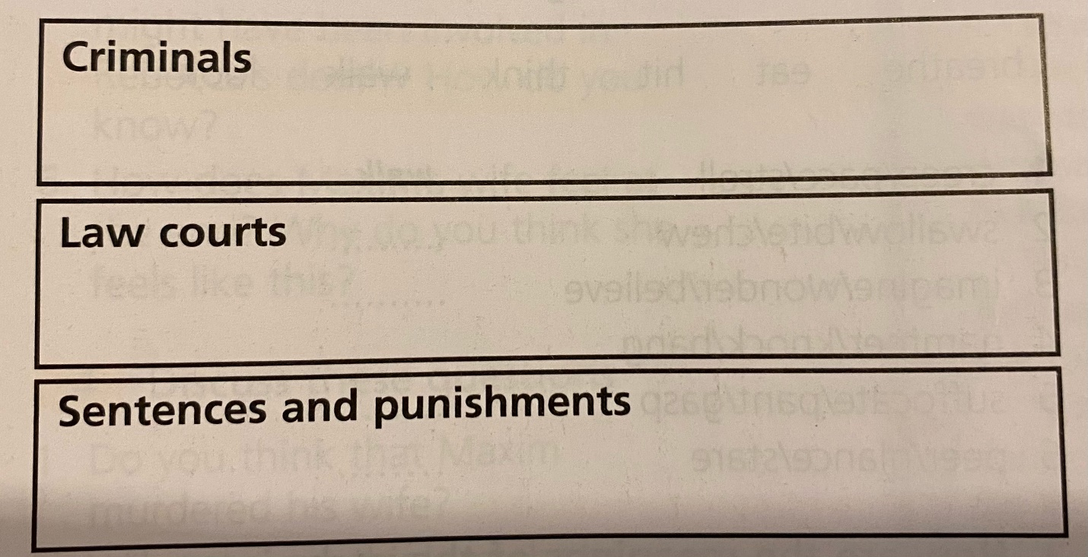

Activity 3 and 4

